**Node + Mongo - Boilerplate API with Email Sign Up, Verification, Authentication & Forgot Password**

**Running the Node + Mongo Boilerplate API Locally**

1. Install NodeJS and NPM from [**https://nodejs.org/en/download/**](https://nodejs.org/en/download/)**.**
2. Install MongoDB Community Server from [**https://www.mongodb.com/download-center/community**](https://www.mongodb.com/download-center/community)**.**
3. Run MongoDB, instructions are available on the install page for each OS at [**https://docs.mongodb.com/manual/administration/install-community/**](https://docs.mongodb.com/manual/administration/install-community/)
4. Download or clone the project source code from [**https://github.com/cornflourblue/node-mongo-signup-verification-api**](https://github.com/cornflourblue/node-mongo-signup-verification-api)**.**

1.CLICK THIS CODE LINK AND DOWNLOAD.

2.AFTER CLICK THE CODE

3.DOWNLOAD ZIP

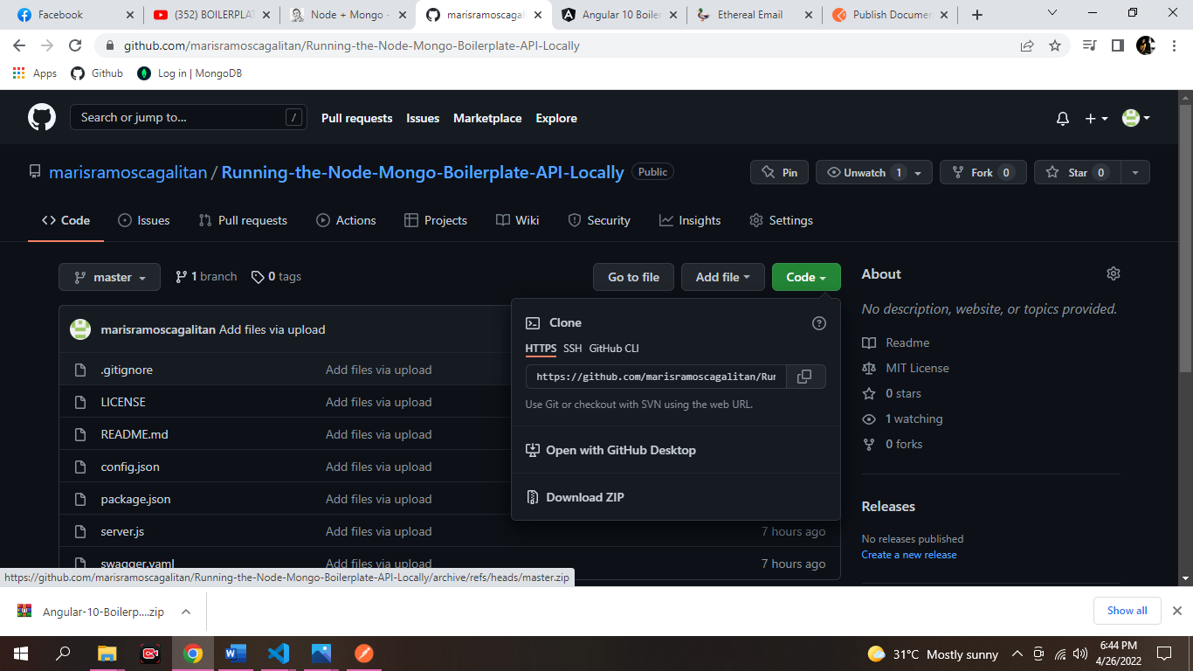

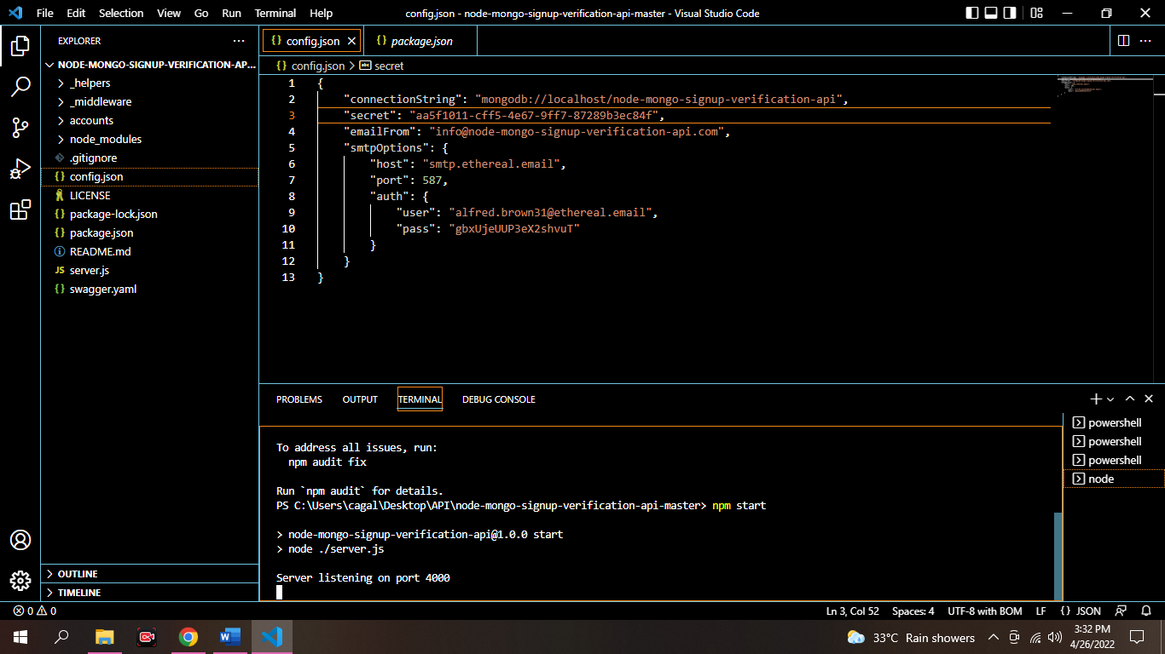6.START the api by running npm start (or npm run start:dev to start with nodemon) from the command line in the project root folder, you should see the message Server listening on port 4000.

4. AFTER DOWNLOADING YOU MAY CLICK THE VISUAL CODE AND CLICK THE FILE INSERT MY FOLDER NAME IS BOILERPLATE API.

WE CAN SEE THE NPM PACKAGE

5. by running npm install or npm i from the command line in the project root folder (where the package.json is located)

7. For testing you can create a free account in one click at https://ethereal.email/ and copy the options below the title Nodemailer configuration.

COPY AND PASTE THE HOST, USER, PASS INTO THE COMMANDLINE

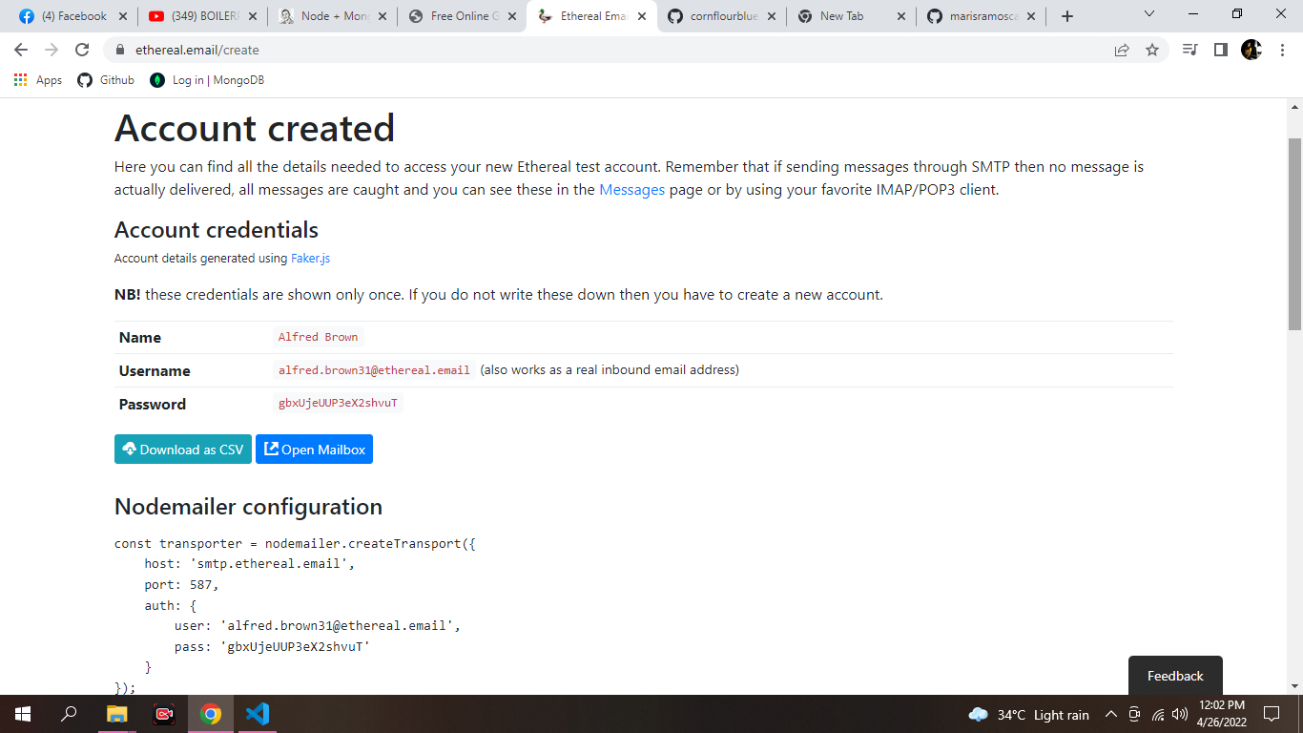

**Running an Angular 10 App with the Node Boilerplate API**

1. Download or clone the Angular 10 tutorial code from <https://github.com/cornflourblue/angular-10-signup-verification-boilerplate>.

AFTER CLICKING THE ANGULAR CODE AS YOU CAN SEE PICTURE BELOW YOU MUST CLICK THE CODE. THEN DOWNLOAD ZIP.

AFTER DOWNLOADING CLICK SHOW IN FOLDER.

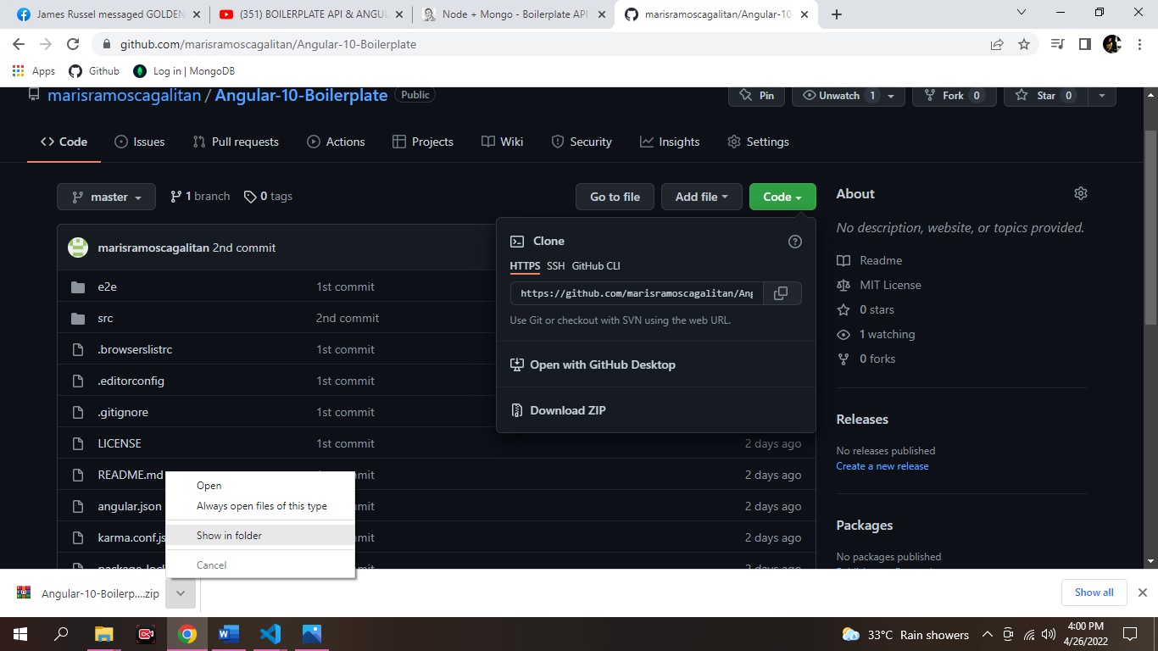

OPEN THE VISUAL STUDIO CODE

CLICK THE FILES THEN SELECT ANGULAR 10 BOILERPLATE- MASTER.

Install all required npm packages by running npm install or npm i from the command line in the project root folder (where the package.json is located).

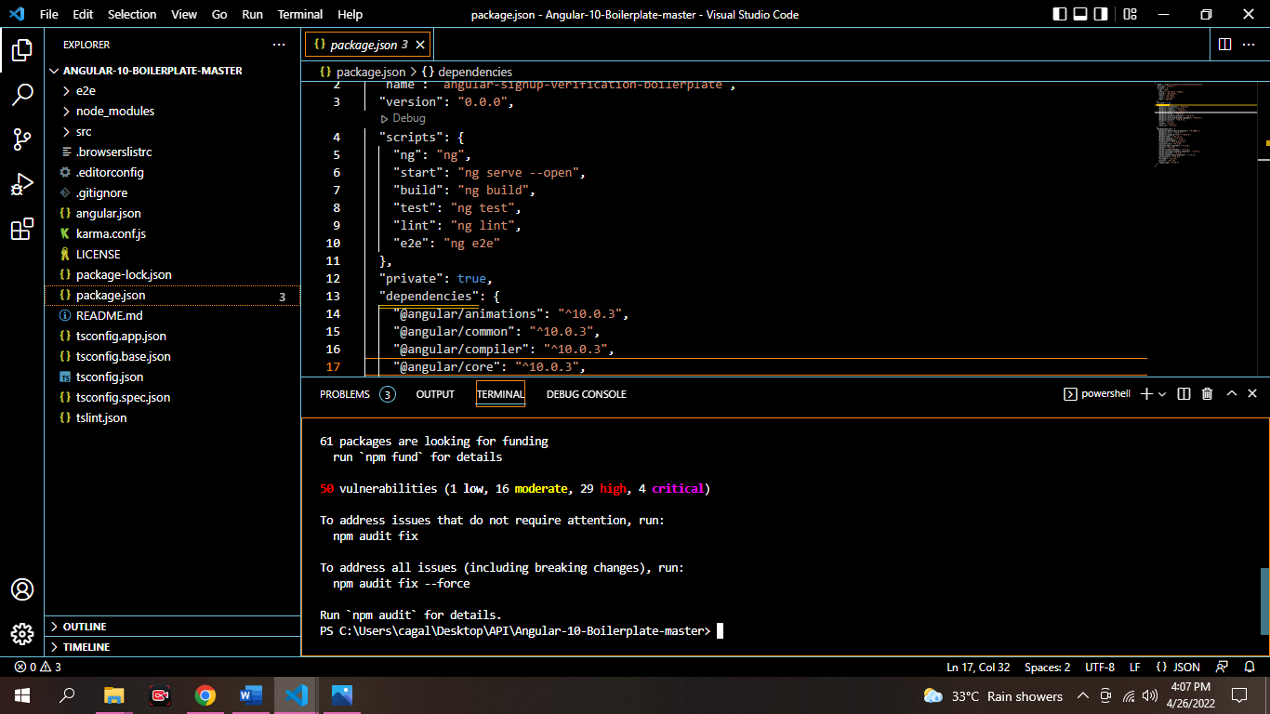

Remove or comment out the 2 lines below the comment // setup fake backend located in the /src/index.jsx file.

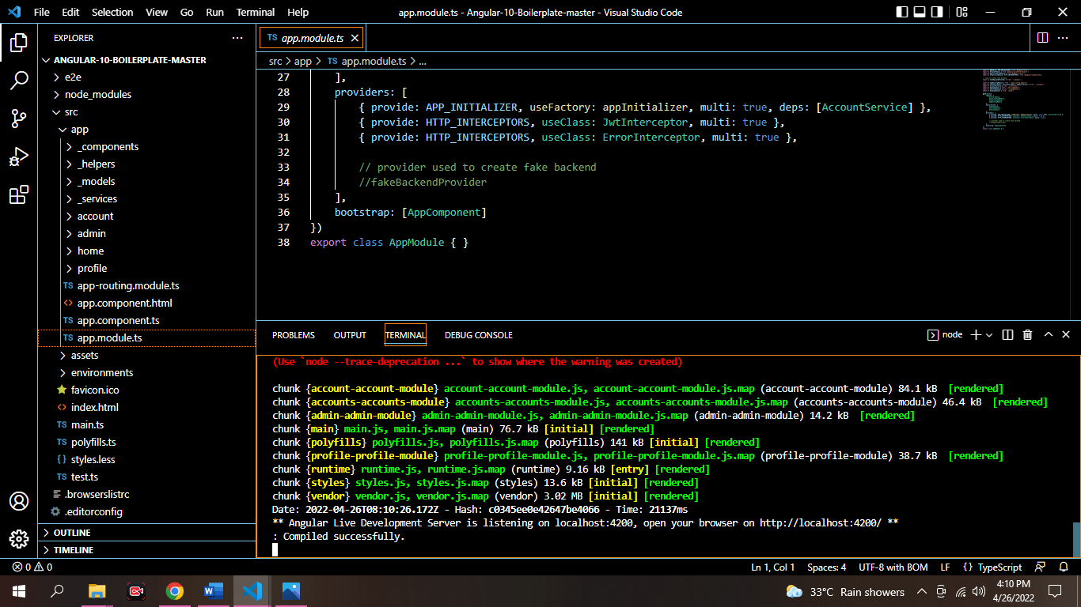

Start the application by running npm start from the command line in the project root folder, this will launch a browser displaying the application and it should be hooked up with the Node + Mongo Boilerplate API that you already have running.

AFTER RUNNING YOU MUST LOG IN Angular 10 Boilerplate email-sign-up-with-verification-authentication-forgot-password

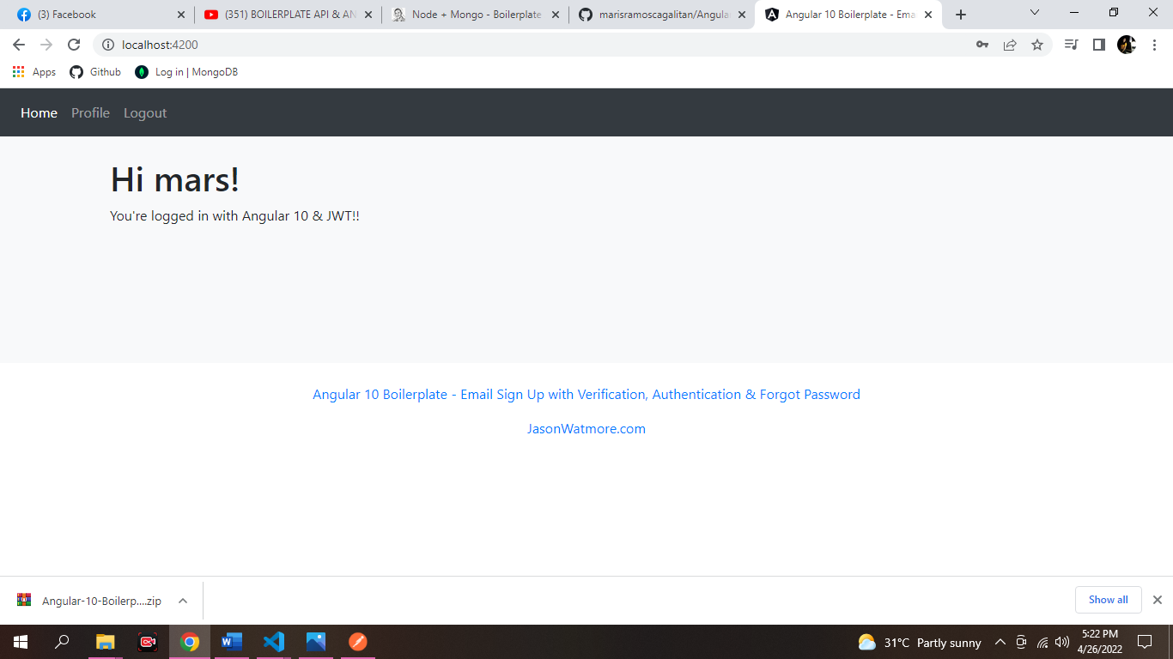

**Testing the Node Boilerplate API with Postman**

Postman is a great tool for testing APIs, you can download it at <https://www.getpostman.com/>.

REGISTRATION

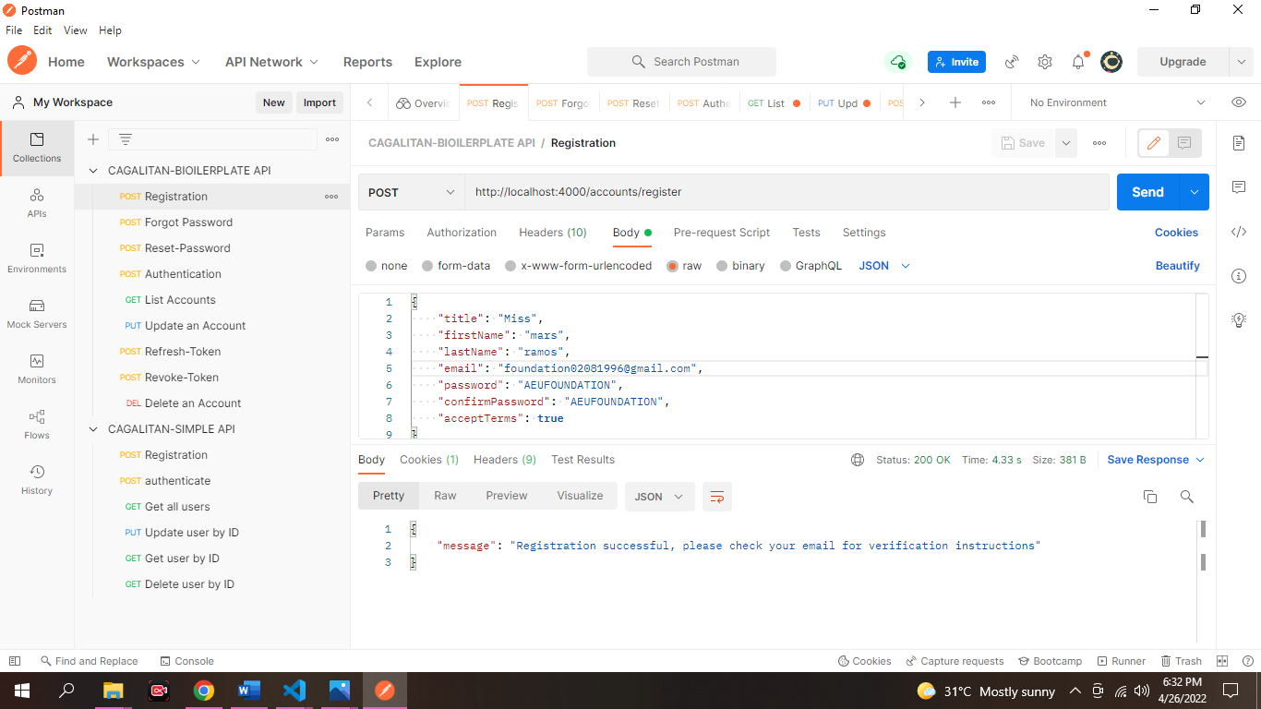

Here's a screenshot of Postman after the request is sent and the new user has been registered:

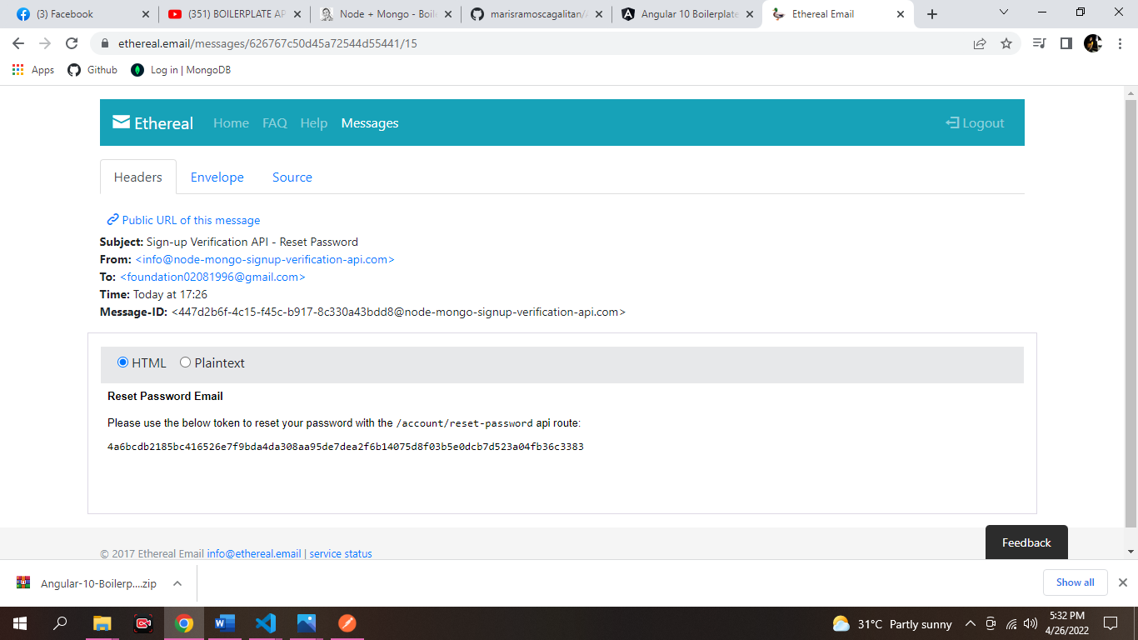

FORGOT PASSWORD

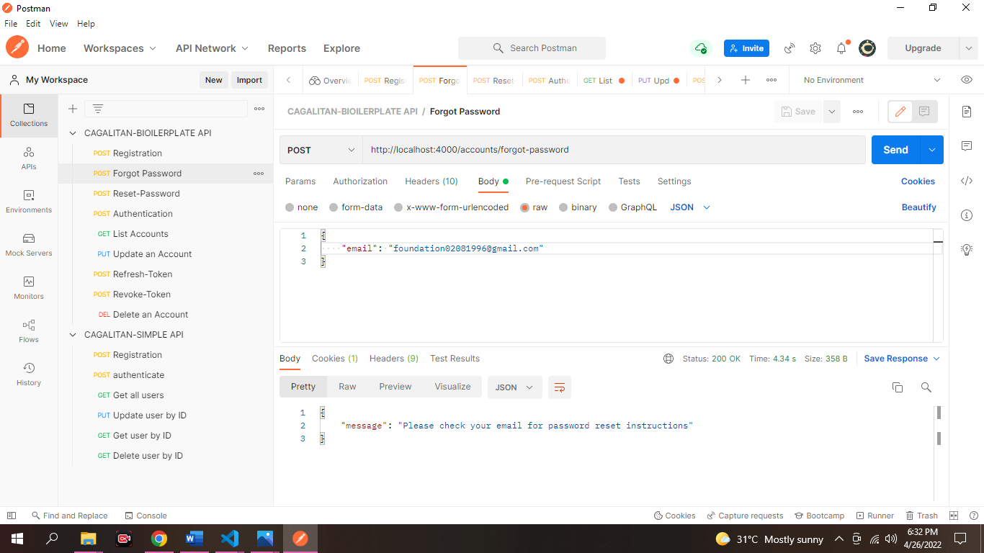

RESET PASSWORD

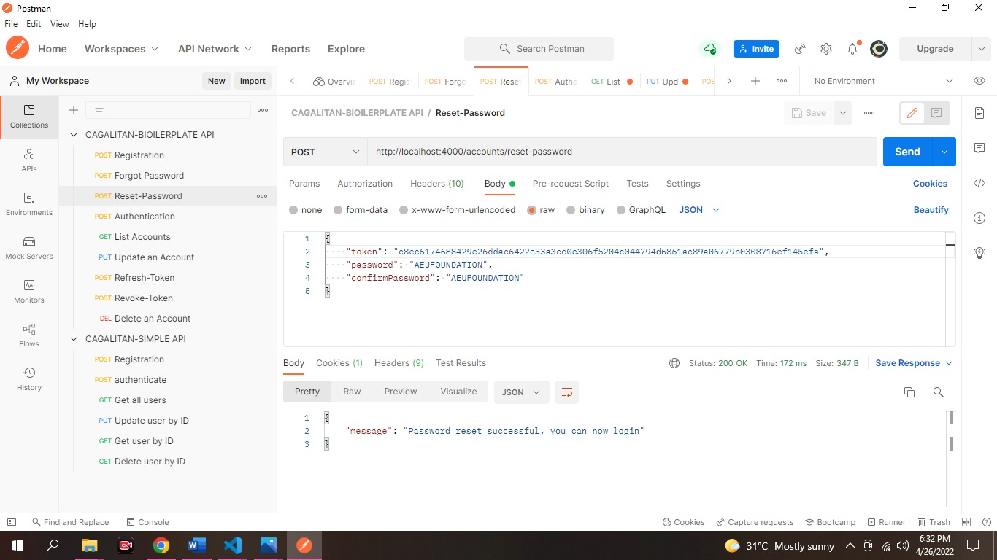

AUTHENTICATION

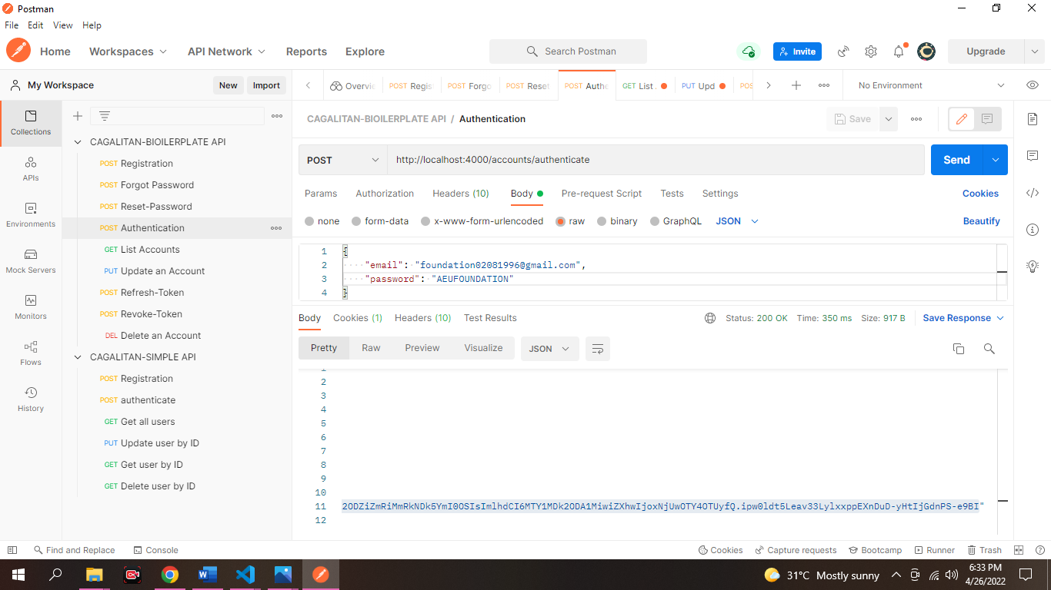

LIST ACCOUNTS

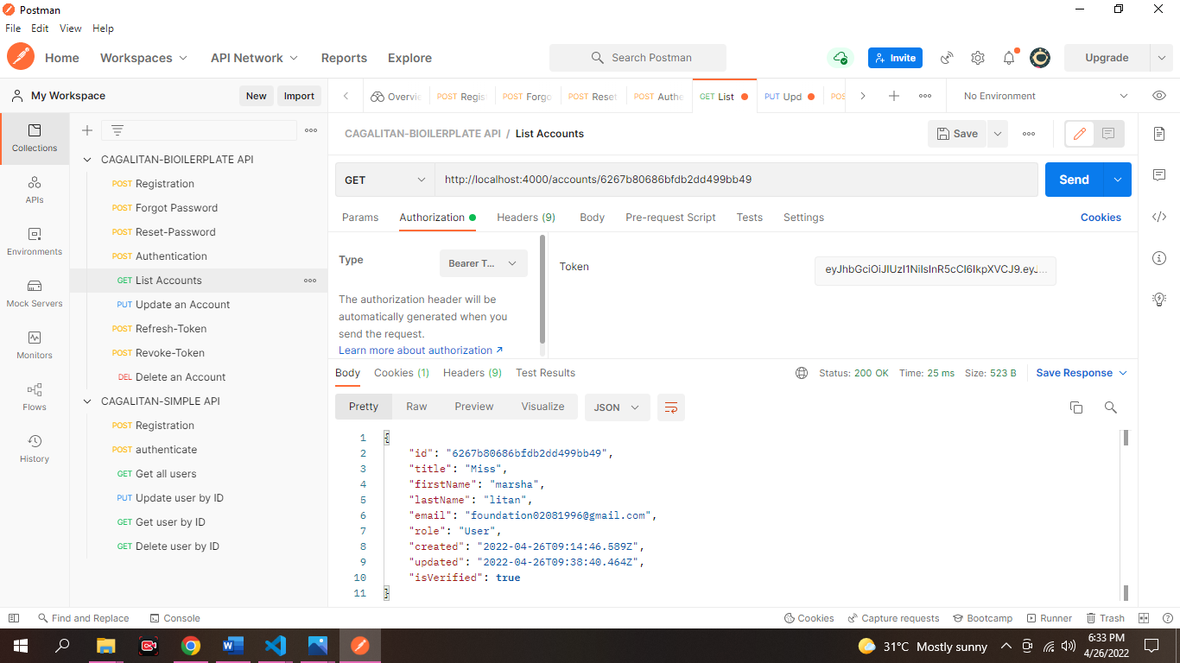

UPDATE AN ACCOUNT

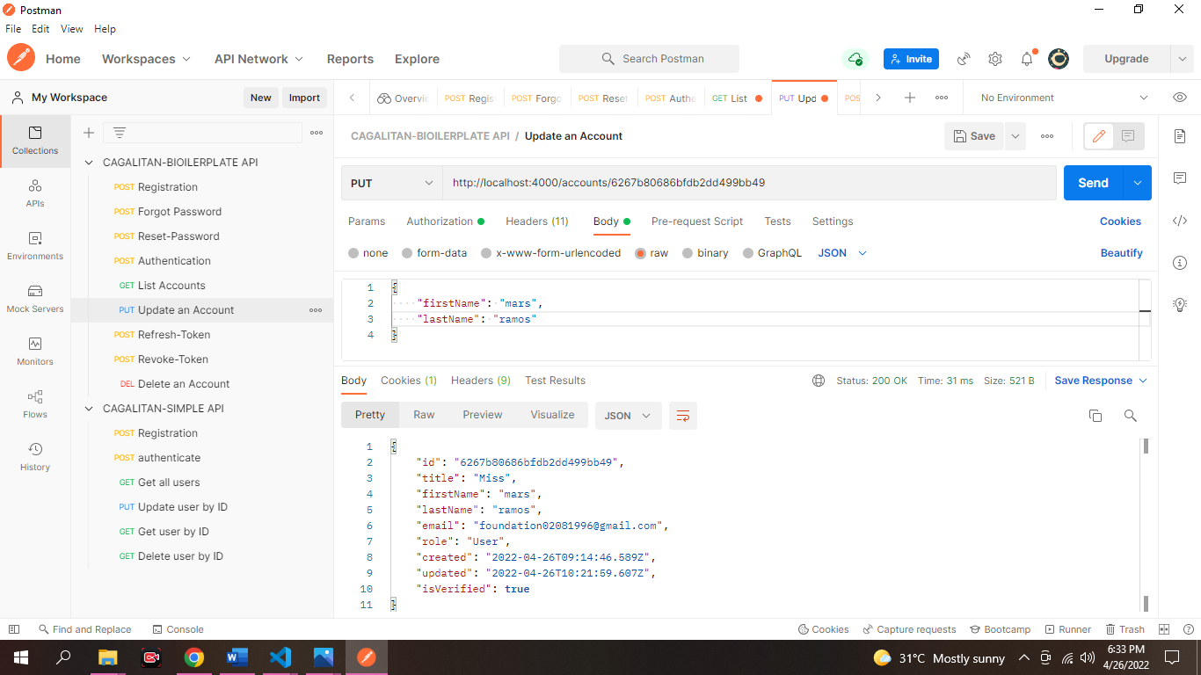

REFRESH-TOKEN

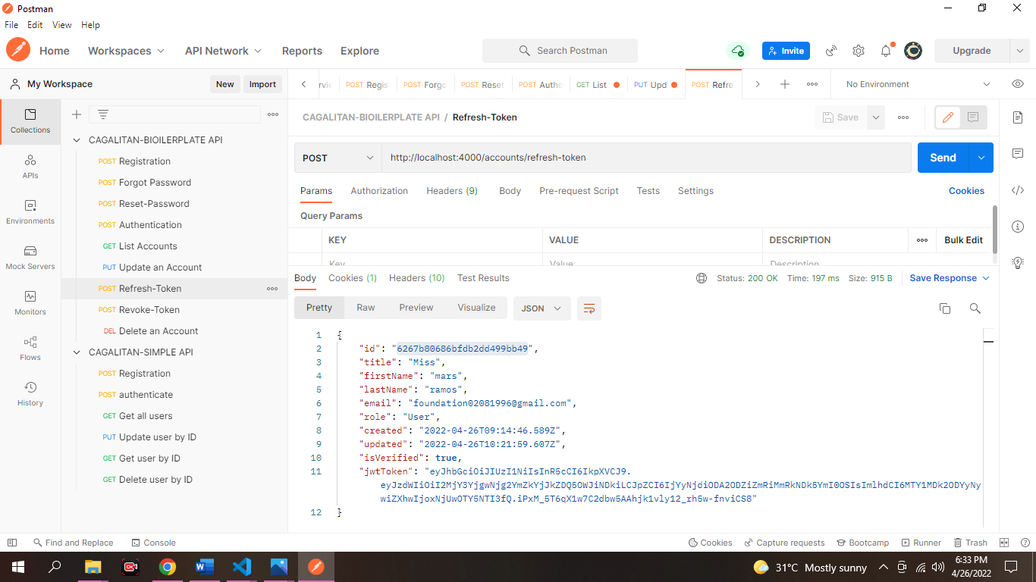

REVOKE-TOKEN

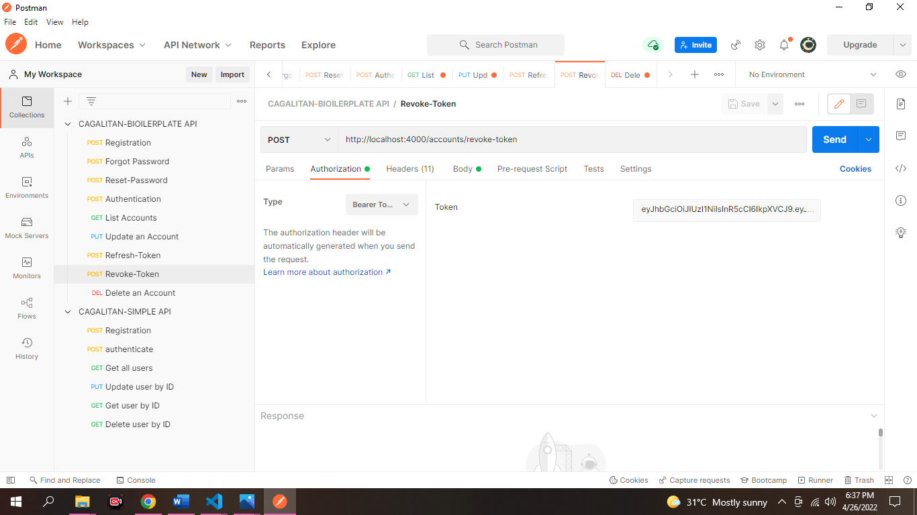

DELETE AN ACCOUNT

